PROPOSED FOOD TECHNOLOGY AND INNOVATION COMPLEX |  | AUGUST, 2022

SUB-SOIL INVESTIGATION REPORT

FOR

THE PROPOSED FOOD TECHNOLOGY AND INNOVATION COMPLEX, BENUE STATE UNIVERSITY, MAKURDI.

PREPARED FOR,

CLIENT: BENUE STATE UNIVERSITY

AUGUST, 2022

CIVIL ENGINEERING DEPARTMENT, FUAM

TABLE OF CONTENTS
1.0 INTRODUCTION 2
1.1 Background 2
1.2 Aim of Study. 2
1.3 Scope of Work 2
2.0 MATERIALS AND METHODS 2
3.0 RESULTS DISCUSSION/INTERPRETATION 3

4.0 CONCLUSION AND RECOMMEDATIONS 4
REFERENCES 5
APPENDIX 6

1.0 INTRODUCTION

1.1 Background
Our Client, Benue State University, Makurdi desirous of carrying out the construction of a Proposed Food Technology and Innovation Complex building commissioned Engr. Boloko A. K. of the Civil Engineering Department of Joseph Sarwuan Tarka University, Makurdi to conduct subsoil investigations.
Makurdi is the Capital city of Benue State. The area experiences a typical tropical climate with distinct dry and wet seasons.
The wet season usually starts in April and ends in October. The dry season begins in November and ends in March. The annual total rainfall ranges from 750-1700mm. The vegetation is mainly savannah, with maximum and minimum mean monthly temperatures of 34ºC and 18ºC respectively.

1.2 Aim of Study.
The purpose of the investigation is to characterize the soil with a view to determine its strength parameters which will form the basis for the safe and economic design of the foundations for the infrastructure,

1.3 Scope of Work
The investigation involved field sampling, laboratory analysis of soil samples for strength parameters and desk studies.

2.0 MATERIALS AND METHODS
Disturbed soil samples were taken from 5 trial pits labelled Pit 1 – Pit 5. The disturbed soil samples were collected at the depth of 2.0 m using a manual auger, digger and shovel. Sampling was done in the month of March, which incidentally corresponds with the dry period in the area.

The following laboratory tests were performed on the samples according to BS 1377 (1990): i. Moisture content
- Particle size distribution test
- Specific gravity iv. Atterberg limits
- Compaction test
- triaxial
- Shear – box test

3.0 RESULTS DISCUSSION/INTERPRETATION
The summary of the results of the laboratory and data analyses are presented in Tables 1 to 3. Detailed results are presented in the appendix. The soil of the site is generally fine sand and can be classified as non-plastic.
The deduced angles of internal friction (Φ) from the plots of the shear strength envelopes for all the samples are shown in the Appendix and are presented in Table 2 with their corresponding cohesion (C) values. The allowable bearing capacity values for the footings at the various pits were calculated based on Terzaghi’s model (see Table 3). It therefore, follows from the Table that the minimum allowable bearing capacity is 111.0 kN/m². On the basis of these, an allowable bearing capacity value of 110 kN/m² will be adequate.

Table 1: Summary of Some Test Results at the Depth of 2.0m
Sample |  | (Mc)  % | (Gs) | LL % | PL % | PI  % | Ls  % | Compaction |  | C kN/m² | Φo | Classification (USCS)
No. | Depth (m) |  |  |  |  |  |  | MDD  kN/m³ | OMC  (%)
P₁ | 2.0 | 14.0 | 2.80 | NP | NP | NP | NP | 1.66 | 9.3 | 0 | 27 | Silty Sand (SM)
P₂ | 2.0 | 26.3 | 2.5 | NP | NP | NP | NP | 1.5 | 12.3 | 0 | 26 | Silty Sand
P₃ | 2.0 | 15.8 | 2.49 | NP | NP | NP | NP | 1.59 | 15.5 | 0 | 26 | Silty Sand with  Clay (SM)
P₄ | 2.0 | 21.5 | 2.7 | NP | NP | NP | NP | 2.0 | 12.0 | 0 | 25 | SC (SM)
P₅ | 2.0 | 14.8 | 2.38 | NP | NP | NP | NP | 1.67 | 18.2 | 0 | 28 | Silty Sand (SM)

Legend: Mc - moisture content Gs - specific gravity LL - liquid limit,
PI - Plasticity index PL - Plastic Limit Ls - Linear shrinkage
K - Permeability Coefficient NP-Non-Plastic SM:- Silty fine Sand
(Φ)-Angle of internal friction C-cohesion q_{a}-Allowable bearing capacity Table 2: Summary of Sample Properties
S/No | Parameters |  |  | Range
1 | Natural Moisture Content, Mc |  |  | 14.0 – 26.3 %
2 | Specific gravity |  | Gs | 2.30 – 2.8 %
3 | Sieve analysis |  | Sand | 96 – 99 %
 |  |  | Silt & Clay | 1.0 – 4.0 %
4 | Atterberg Limits |  | LL | NP
 |  |  | PI | NP
 |  |  | Ls | NP
5 | Compaction |  | MDD | 1.5 – 2.0 kg/m²
 |  |  | OMC | 9.3 – 18.0 %
6 | Direct share test |  | Cu | 0.0 – 0.0 kN/m²
 |  |  | ɸo | 25.0 – 28.0⁰
 |  |  | ϒ | 18.0 – 18.6 kN/m²

Table 3: Allowable bearing capacity using results from the Shear Box test
Bore-  hole No. | Depth  Z (m) | Undrained cohesion, C  (kN/m²) | Angle of int. friction ɸ(degrees) | Unit weight ϒ  (kN/m²) | Nc | Nq | Nϒ | Qunet  (kN/m²) | Qsafe  (kN/m²)
Pit 1 | 2.0 | 0 | 27 | 18.2 | 23.9 | 13.2 | 9.3 | 276 | 111.0
Pit 2 | 2.0 | 0 | 26 | 16.4 | 32.4 | 20.5 | 17.5 | 430 | 173.0
Pit 3 | 2.0 | 0 | 26 | 18.6 | 6.5 | 1.6 | 8.2 | 342 | 137.0
Pit 4 | 2.0 | 0 | 25 | 16.5 | 8.5 | 2.6 | 8.4 | 364 | 145.0
Pit 5 | 2.0 | 0 | 28 | 18.4 | 25.8 | 14.7 | 10.9 | 390 | 156.0

4.0 CONCLUSION AND RECOMMEDATIONS
The processes of field observation/sampling of subsoil, laboratory analyses and discussion of results have being presented in this report. This investigation has revealed that the soil is mainly Silty Sand.
It is therefore, recommended that an allowable bearing capacity of 110 kN/m² should be adopted for foundation design at the proposed depth of 2.0 m.
We shall be available if our services are required in the course of execution of this project.

Engr. Boloko Augustine K.
Senior Chief Engineering Technologist
Civil Engineering Department, JOSTUM.
REFERENCES
BS1377 (1990) Methods of Test for Soils for Civil Engineering Purposes, part 2. British Standard Institution London
Ola, S.A. (1983) Geotechnical Properties of Sokoto Clay Shales of Northern Nigeria. In Tropical soils of Nigeria in Engineering Practice .Edited by S.A. Ola Pp131-144
Whitlow, R. (1990): Basic Soil Mechanics 2nd edition, Longman Group UK Ltd. Pp 376.
ASTM D2487 (1948) as Unified Soil Classification System (USC)

APPENDIX

NATURAL MOISTURE CONTENT DETERMINATION RESULT
Project: Proposed Food Technology and Innovation Complex
Contractor: Date: 14/07/2022
(Pits)
Sample No. | Pit 1 |  | Pit 2
Depth of sample (m) | 2.0 m |  | 2.0 m
Container No. | 24 | 20 | 60 | 71
Mass of container + wet soil (g) | 67.0 | 67.6 | 54.5 | 65.8
Mass of container + dry soil (g) | 60.1 | 61.9 | 46.6 | 45.4
Mass of container (g) | 14.2 | 18.0 | 17.2 | 16.0
Mass of dry soil (g) | 45.9 | 43.9 | 29.4 | 29.4
Mass of moisture (g) | 6.9 | 5.7 | 7.9 | 7.6
Moisture content (%) | 15.0 | 13.0 | 26.8 | 25.8
Average moisture content (%) | 13.9 |  | 26.3

Sample No. | Pit 3 |  | Pit 4
Depth of sample (m) | 2.0 m |  | 2.0 m
Container No. | 4 | 1 | 7 | 5
Mass of container + wet soil (g) | 67.7 | 80.0 | 62.2 | 61.7
Mass of container + dry soil (g) | 62.0 | 68.9 | 54.3 | 53.5
Mass of container (g) | 11.7 | 14.0 | 16.7 | 16.3
Mass of dry soil (g) | 50.3 | 54.9 | 37.6 | 37.2
Mass of moisture (g) | 5.7 | 11.1 | 7.9 | 8.2
Moisture content (%) | 11.3 | 20.2 | 21.0 | 22.0
Average moisture content (%) | 16.0 |  | 21.5

NATURAL MOISTURE CONTENT DETERMINATION RESULT
Project: Proposed Food Technology and Innovation Complex
Contractor: Date: 14/07/2022
Pits
Sample No. | Pit 5
Depth of sample (m) | 2.0 m
Container No. | 8 | 3
Mass of container + wet soil (g) | 52.5 | 64.0
Mass of container + dry soil (g) | 48.2 | 57.3
Mass of container (g) | 17.2 | 14.8
Mass of dry soil (g) | 31.0 | 42.8
Mass of moisture (g) | 4.3 | 6.7
Moisture content (%) | 13.9 | 15.7
Average moisture content (%) | 14.8

PROPOSED FOOD TECHNOLOGY AND INNOVATION COMPLEX |  |  | AUGUST, 2022

SPECIFIC GRAVITY OF SAMPLES
Sample No. | Pit 1 |  | Pit 2 |  | Pit 3 |  | Pit 4 |  | Pit 5
Depth | 2.0 m | 2.0 m | 2.0 m | 2.0 m | 2.0 m | 2.0 m | 2.0 m | 2.0 m | 2.0 m | 2.0 m
Mass of jar + soil + water (m₃) | 78.8 | 78.5 | 85.4 | 85.5 | 77.9 | 78.8 | 85.6 | 85.5 | 78.8 | 76.8
Mass of jar + soil (m₂) (g) | 32.4 | 31.9 | 46.6 | 46.7 | 31.8 | 32.4 | 45.7 | 46.6 | 32.4 | 31.7
Mass of jar + water (m₄) (g) | 71.8 | 71.8 | 20.5 | 20.5 | 71.8 | 71.8 | 20.5 | 20.5 | 71.8 | 71.8
Mass of jar (m₁) (g) | 21.5 | 21.5 | 70.0 | 70.0 | 21.5 | 21.5 | 70.0 | 70.0 | 21.5 | 21.5
M₂ – m₁ | 10.9 | 10.4 | 26.1 | 26.2 | 10.3 | 10.9 | 25.2 | 26.1 | 10.9 | 10.2
M₄ – m₁ | 50.3 | 50.3 | 49.5 | 49.5 | 50.3 | 50.3 | 49.5 | 49.5 | 50.3 | 50.3
M₃ – m₂ | 46.4 | 46.6 | 38.8 | 38.8 | 46.1 | 46.0 | 37.9 | 38.9 | 46.4 | 45.1
(m₄ – m₁) – (m₃ – m₂) | 3.9 | 3.7 | 10.7 | 10.7 | 4.2 | 4.3 | 9.6 | 10.6 | 3.9 | 5.2
Gs = (m₂ – m₁)/[(m₄ – m₁)-(m₃ – m₂)] | 2.79 | 2.81 | 2.44 | 2.45 | 2.45 | 2.53 | 2.63 | 2.46 | 2.79 | 1.96
Average | 2.80 |  | 2.5 |  | 2.50 |  | 2.7 |  | 2.40

11

CIVIL ENGINEERING DEPARTMENT, JOSTUM

GRAIN SIZE ANALYSIS RESULT (pit 1)
Sieve Diameter | Mass Retained | % Retained | %Passing
20 mm | - | - | 100
14 mm | - | - | 100
10 mm | - | - | 100
6.3 mm | - | - | 100
5.3 mm | - | - | 100
3.35mm | - | - | 100
2.36mm | 1 | 0.2 | 99.8
1.7mm | 2.2 | 0.44 | 99.36
1.18mm | 6.1 | 1.22 | 98.14
850µm | 16.6 | 3.36 | 94.98
600µm | 74.7 | 14.94 | 79.84
425µm | 122.2 | 24.44 | 55.40
300µm | 130.5 | 26.1 | 29.30
150µm | 109.1 | 21.82 | 9.48
75µm | 20.6 | 4.12 | 3.36
Passing | 16.8 | 3.36 | -

PROPOSED FOOD TECHNOLOGY AND INNOVATION COMPLEX |  | AUGUST, 2022

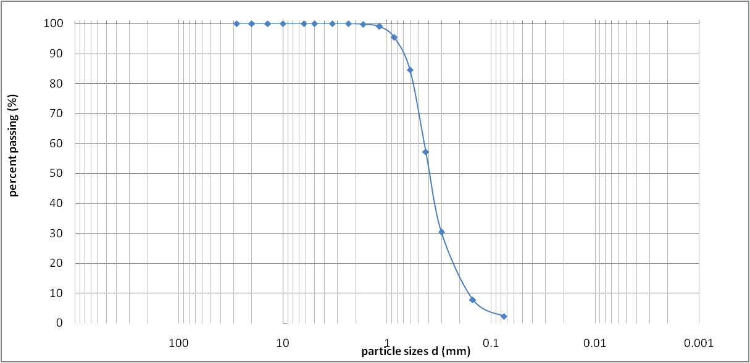
Cobles | Gravel |  |  | Sand |  | Silt | Clay
 | Coarse | Fine | Coarse | Medium | Fine

Figure 1: Particle size distribution of Pit 1
13

CIVIL ENGINEERING DEPARTMENT, JOSTUM

GRAIN SIZE ANALYSIS RESULT (pit 2)
Sieve Diameter | Mass  Retained | % Retained | %Passing
20 mm | - | - | 100
14 mm | - | - | 100
10 mm | - | - | 100
6.3 mm | - | - | 100
5 mm | - | - | 100
3.35mm | 7.4 | 1.48 | 98.52
2.36mm | 3.8 | 0.76 | 97.75
1.7mm | 4.8 | 0.96 | 96.8
1.18mm | 7.5 | 1.5 | 95.3
850µm | 17.4 | 3.48 | 91.82
600µm | 50.9 | 10.18 | 81.64
425µm | 195.6 | 39.12 | 42.52
300µm | 111.4 | 22.28 | 20.24
150µm | 87.7 | 17.54 | 2.70
75µm | 0.8 | 2.16 | 0.54
Passing | 2.7 | 0.54 | -

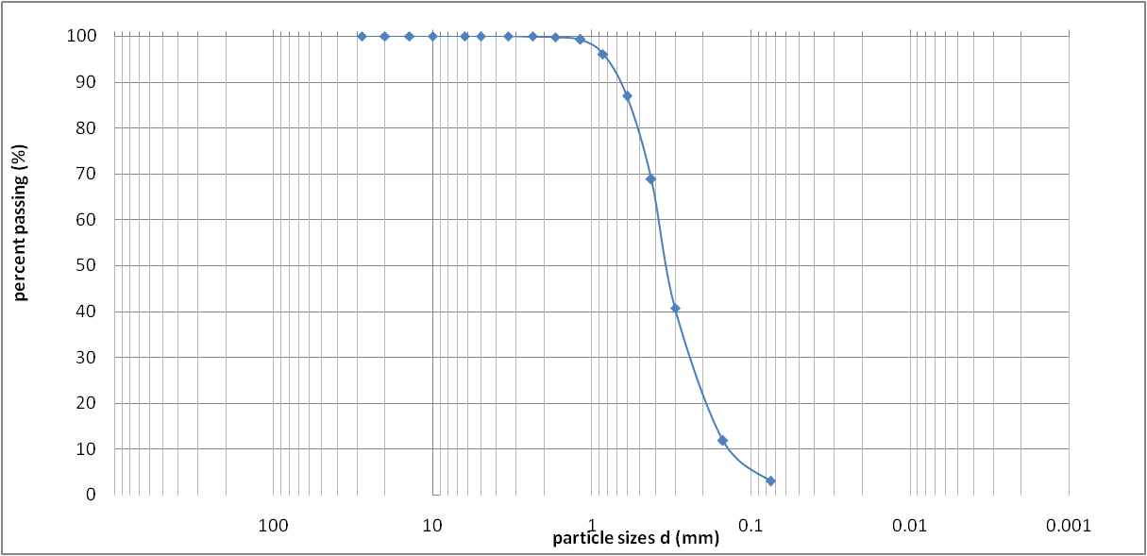
Cobles | Gravel |  |  | Sand |  | Silt | Clay
 | Coarse | Fine | Coarse | Medium | Fine

Figure 2: Particle size distribution of Pit 2

GRAIN SIZE ANALYSIS RESULT (pit 3)
Sieve Diameter | Mass  Retained | % Retained | %Passing
20 mm | - | - | 100
14 mm | - | - | 100
10 mm | - | - | 100
6.3 mm | - | - | 100
5mm | - | - | 100
3.35mm | 0.7 | 0.14 | 99.86
2.36mm | 1.0 | 0.2 | 99.66
1.7mm | 2.7 | 0.54 | 99.12
1.18mm | 7.6 | 1.52 | 97.60
850µm | 15.6 | 3.12 | 94.48
600µm | 95.2 | 19.04 | 75.44
425µm | 170.4 | 34.08 | 41.36
300µm | 127.6 | 25.52 | 15.84
150µm | 66.4 | 13.28 | 2.56
75µm | 8.3 | 1.66 | 0.9
Passing | 4.5 | 0.9 | -

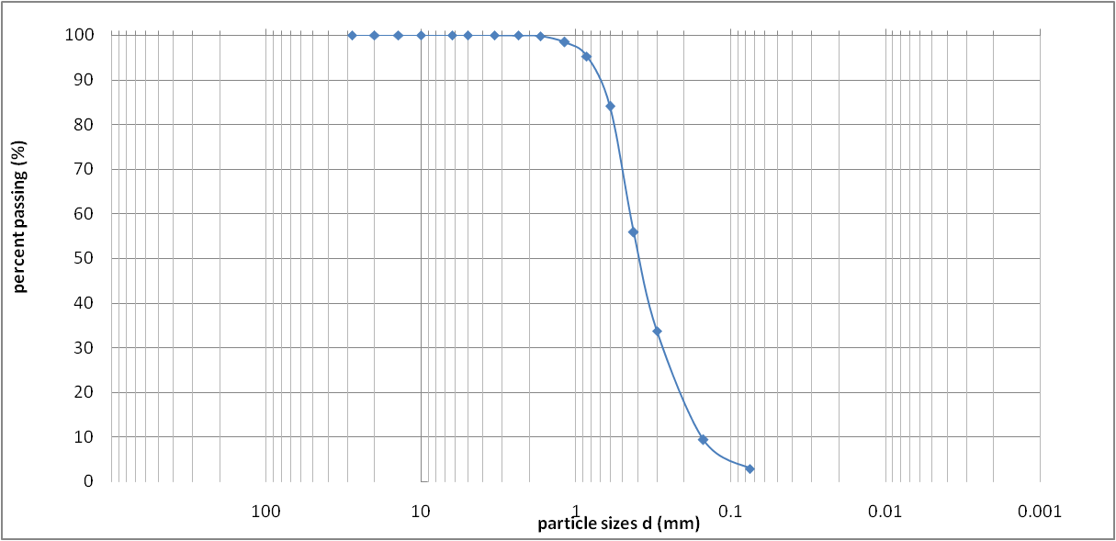
Cobles | Gravel |  |  | Sand |  | Silt | Clay
 | Coarse | Fine | Coarse | Medium | Fine

Figure 3: Particle size distribution of Pit 3

GRAIN SIZE ANALYSIS RESULT (pit 4
Sieve Diameter | Mass  Retained | % Retained | %Passing
20 mm | - | - | 100
14 mm | - | - | 100
10 mm | - | - | 100
6.3 mm | - | - | 100
5mm | - | - | 100
3.35mm | - | - | 100
2.36mm | - | - | 100
1.7mm | 1.70 | 0.34 | 99.66
1.18mm | 5.30 | 1.06 | 98.6
850µm | 22.3 | 4.46 | 94.14
600µm | 81.8 | 16.36 | 77.78
425µm | 176.8 | 35.36 | 42.42
300µm | 112.9 | 22.58 | 19.84
150µm | 83.8 | 16.76 | 3.08
75µm | 9.50 | 1.9 | 1.18
Passing | 5.90 | 1.18 | -

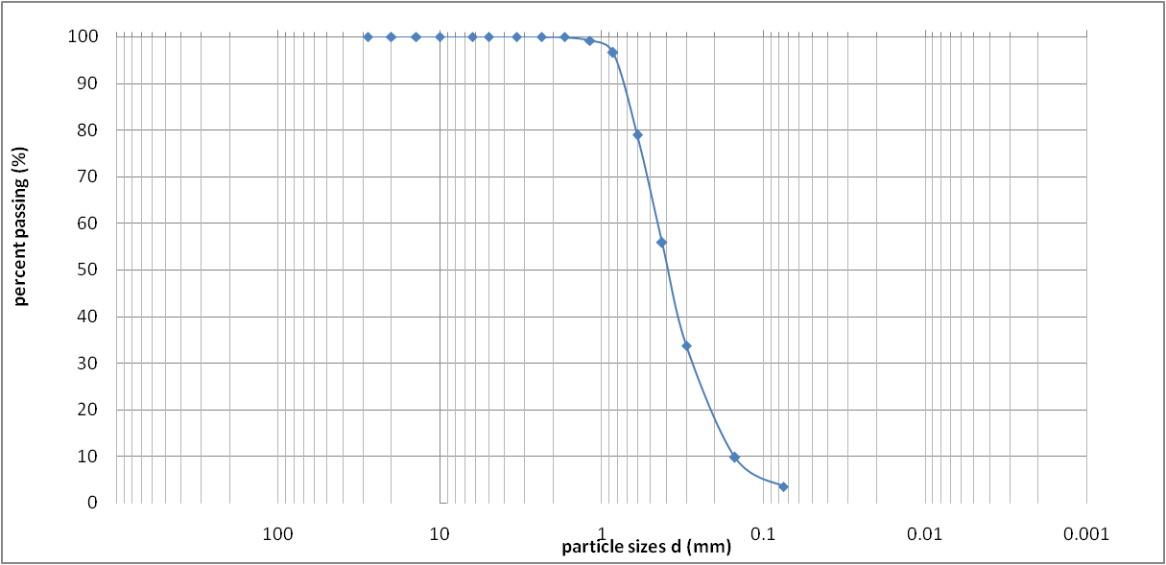
Cobles | Gravel |  |  | Sand |  | Silt | Clay
 | Coarse | Fine | Coarse | Medium | Fine

Figure 4: Particle size distribution of Pit 4

GRAIN SIZE ANALYSIS RESULT Pit 5
Sieve Diameter | Mass  Retained | % Retained | %Passing
20 mm | - | - | 100
14 mm | - | - | 100
10 mm | - | - | 100
6.3 mm | - | - | 100
5mm | - | - | 100
3.35mm | 25.3 | 5.06 | 94.94
2.36mm | 4.3 | 0.86 | 94.08
1.7mm | 4.0 | 0.8 | 93.28
1.18mm | 7.2 | 1.44 | 91.84
850µm | 21.8 | 4.36 | 87.48
600µm | 47.0 | 9.4 | 78.08
425µm | 177.2 | 35.44 | 42.64
300µm | 111.6 | 22.32 | 20.32
150µm | 77.6 | 15.52 | 4.8
75µm | 9.5 | 1.9 | 2.9
Passing | 14.5 | 2.9 | -

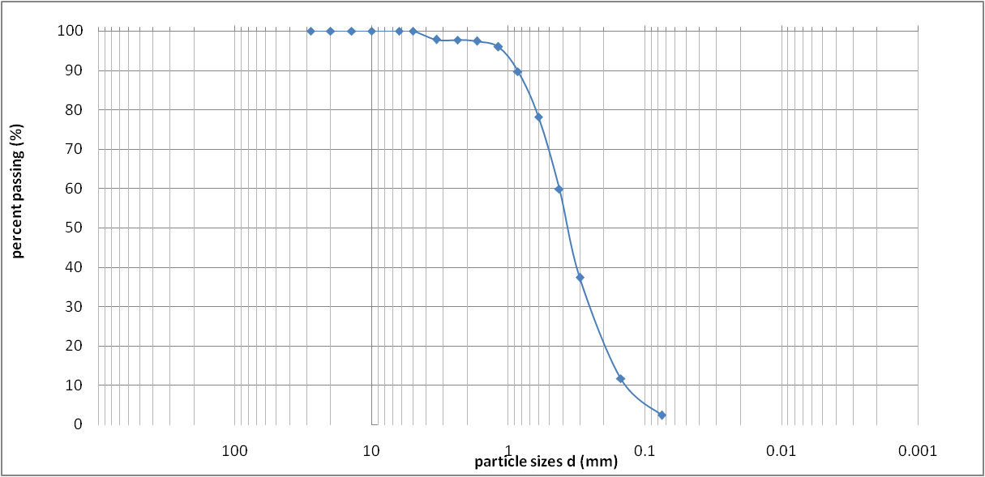
Cobles | Gravel |  |  | Sand |  | Silt | Clay
 | Coarse | Fine | Coarse | Medium | Fine

Figure 5: Particle size distribution of Pit 5

LIQUID, PLASTIC LIMITS AND LINEAR SHRINKAGE
Project: Proposed Food Technology and Innovation Complex
Client: Benue State University, Makurdi Date: 18/07/2022
Borehole No: |  | Sample No. Pit 1 |  |  | Depth (m) |  |  | 2.0 m
Total weight of sample (g) |  |  | Weight passing No.40(0.425mm |  |  |  | ) sieve
Soil/water curing time(hr) |  |  | %passing No.40 (0.425 mm) sie |  |  |  | ve
Test |  | Plastic Limits |  |  | Liquid limit
Number of Can/No .of blows
Weight of Can + wet soil g
Weight of Can + Dry soil g
Weight of moisture g
Wt. of container g
Weight of dry soil g
Wt of moisture %
Average %

Liquid limit (LL) % |  | Linear shrinkage LS =(L₁-L₂/ L₁ ) x 100
Plastic limit (PL) % |  | L₁= Initial length of specimen (mm) | 140
Plastic Index(PI) % |  | L₂= Final length of specimen (mm)
Liquid Index(LI) %
Linear Shrinkage (LS) %
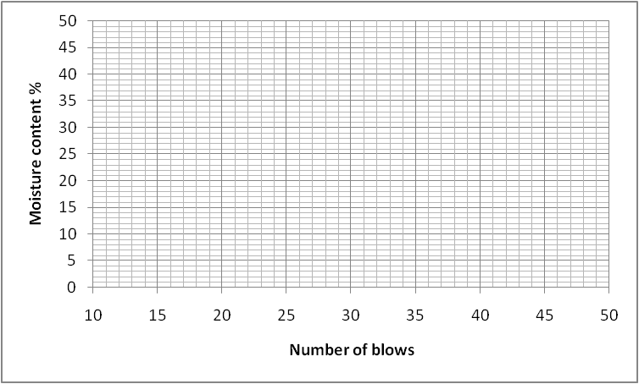
Ajoh Engr. Boloko A. K

NON PLASTIC

Project: Proposed Food Technology and Innovation Complex
Client: Benue State University, Makurdi
Borehole No: |  | Sample No. Pit 2 |  |  | Depth (m) |  |  | 2.0 m
Total weight of sample (g) |  |  | Weight passing No.40(0.425mm |  |  |  | ) sieve
Soil/water curing time(hr) |  |  | %passing No.4 0 (0.425mm) sie |  |  |  | ve
Test |  | Plastic Limits |  |  | Liquid limit
Number of Can/No .of blows
Weight of Can + wet soil g
Weight of Can + Dry soil g
Weight of moisture g
Wt. of container g
Weight of dry soil g
Wt of moisture %
Average %

Liquid limit (LL) % |  | Linear shrinkage LS =(L₁-L₂/ L₁ ) x 100
Plastic limit (PL) % |  | L₁= Initial length of specimen (mm) | 140
Plastic Index(PI) % |  | L₂= Final length of specimen (mm)
Liquid Index(LI) %
Linear Shrinkage (LS) %
Ajoh Engr. Boloko A. K

NON PLASTIC

Project: Proposed Food Technology and Innovation Complex
Client: Benue State University, Makurdi
Borehole No: |  | Sample No. Pit 3 |  |  | Depth (m) |  |  | 2.0 m
Total weight of sample (g) |  |  | Weight passing No.40(0.425mm |  |  |  | ) sieve
Soil/water curing time(hr) |  |  | %passing No.4 0 (0.425mm) sie |  |  |  | ve
Test |  | Plastic Limits |  |  | Liquid limit
Number of Can/No .of blows
Weight of Can + wet soil g
Weight of Can + Dry soil g
Weight of moisture g
Wt. of container g
Weight of dry soil g
Wt of moisture %
Average %

Liquid limit (LL) % |  | Linear shrinkage LS =(L₁-L₂/ L₁ ) x 100
Plastic limit (PL) % |  | L₁= Initial length of specimen (mm) | 140
Plastic Index(PI) % |  | L₂= Final length of specimen (mm)
Liquid Index(LI) %
Linear Shrinkage (LS) %
Ajoh Engr. Boloko A. K

NON PLASTIC

Project: Proposed Food Technology and Innovation Complex
Client: Benue State University, Makurdi
Borehole No: |  | Sample No. Pit 4 |  |  | Depth (m) |  |  | 2.0 m
Total weight of sample (g) |  |  | Weight passing No.40(0.425mm) sieve
Soil/water curing time(hr) |  |  | %passing No.40 (0.425mm) sieve
Test |  | Plastic Limits |  |  | Liquid limit
Number of Can/No .of blows
Weight of Can + wet soil g
Weight of Can + Dry soil g
Weight of moisture g
Wt. of container g
Weight of dry soil g
Wt of moisture %
Average %

NON PLASTIC

Liquid limit (LL) % |  | Linear shrinkage LS =(L₁-L₂/ L₁ ) x 100
Plastic limit (PL) % |  | L₁= Initial length of specimen (mm) | 140
Plastic Index(PI) % |  | L₂= Final length of specimen (mm)
Liquid Index(LI) %
Linear Shrinkage (LS) %

Operator: Ajoh Checked: Engr. Boloko A. K Date: 18/07/22
Project: Proposed Food Technology and Innovation Complex
Client: Benue State University, Makurdi
Borehole No: |  | Sample No. Pit 5 |  |  | Depth (m) |  |  | 2.0 m
Total weight of sample (g) |  |  | Weight passing No.40(0.425mm |  |  |  | ) sieve
Soil/water curing time(hr) |  |  | %passing No.4 0 (0.425mm) sie |  |  |  | ve
Test |  | Plastic Limits |  |  | Liquid limit
Number of Can/No .of blows
Weight of Can + wet soil g
Weight of Can + Dry soil g
Weight of moisture g
Wt. of container g
Weight of dry soil g
Wt of moisture %
Average %

NON PLASTIC

Liquid limit (LL) % |  | Linear shrinkage LS =(L₁-L₂/ L₁ ) x 100
Plastic limit (PL) % |  | L₁= Initial length of specimen (mm) | 140
Plastic Index(PI) % |  | L₂= Final length of specimen (mm)
Liquid Index(LI) %
Linear Shrinkage (LS) %

Operator: Ajoh Checked: Engr. Boloko A. K Date: 18/07/22
Benue State University
Description: (Pit 1) Date: 27/07/22
No. of layers: 3 No. of blows: 27
Wt. of mould: 3342 g Vol. of mould (v): 1000

3% 6% 9% 12% 15%
1. Test No. | 1 | 2 | 3 | 4 | 5
2. Container No. | 133 | 120 | 2 | 15 | 28
3. Wt. of Container + Wet Soil | 76.1 | 92.8 | 95.7 | 100.6 | 108.1
4. Wt. of Container + Dry Soil | 74.3 | 76.2 | 89.2 | 91.3 | 96.1
5. Wt. of Container | 16.4 | 16.3 | 16.3 | 16.0 | 16.2
6. Wt. of Moisture | 1.8 | 3.6 | 5.5 | 9.3 | 12.0
7. Wt. of Dry Soil | 57.9 | 59.9 | 59 | 75.3 | 79.9
8. Moisture Content (m %) | 3.1 | 6.0 | 9.3 | 12.0 | 15.0
9. Wt. of Mould + wet Soil ( ) | 5005 | 5060 | 5240 | 5226 | 5220
10. Wt. of Wet Soil (w) | 1480 | 1540 | 1720 | 1706 | 1700
11. Bulk Density D_{w}= | 1.48 | 1.54 | 1.72 | 1.71 | 1.70
12. Dry Density= | 1.44 | 1.45 | 1.57 | 1.53 | 1.48
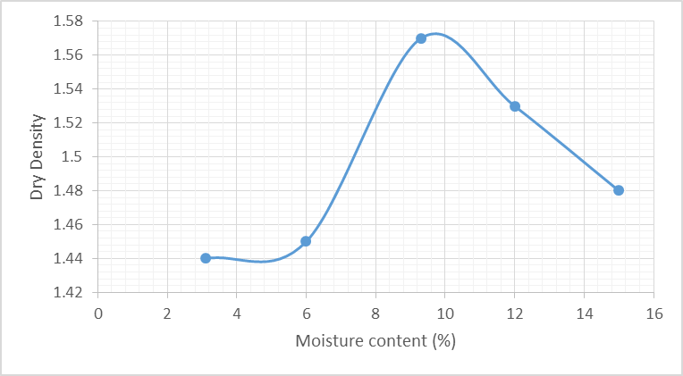
_{Form S5} MAX. DRY DENSITY: 1.57 Kg. /Cum OPTIMUM M/C: 9.3 %
Operator: K.A Boloko Checked: Engr. K. A. Boloko Date: 27/07/22

Description: (Pit 2)
No. of layers: 3 No. of blows: 27
Wt. of mould: 3342 g Vol. of mould (v): 1000

9% 12% 15% 18% 21%
1. Test No. | 1 | 2 | 3 | 4 | 5
2. Container No. | 28 | 63 | 83 | 133 | 90
3. Wt. of Container + Wet Soil | 62.8 | 63.4 | 92.8 | 84.2 | 85.8
4. Wt. of Container + Dry Soil | 58.8 | 58.3 | 82.4 | 73.7 | 71.8
5. Wt. of Container | 16.2 | 16.8 | 16.5 | 16.4 | 17.0
6. Wt. of Moisture | 4.0 | 5.1 | 9.9 | 10.5 | 14.0
7. Wt. of Dry Soil | 42.6 | 41.5 | 65.9 | 57.3 | 68.0
8. Moisture Content (m %) | 9.4 | 12.3 | 15.0 | 18.3 | 20.6
9. Wt. of Mould + wet Soil ( ) | 5152 | 5222 | 5346 | 5225 | 5161
10. Wt. of Wet Soil (w) | 1810 | 1880 | 2004 | 1883 | 1820
11. Bulk Density D_{w}= | 1.81 | 1.88 | 2.00 | 1.88 | 1.82
12. Dry Density= | 1.65 | 1.67 | 1.74 | 1.60 | 1.51
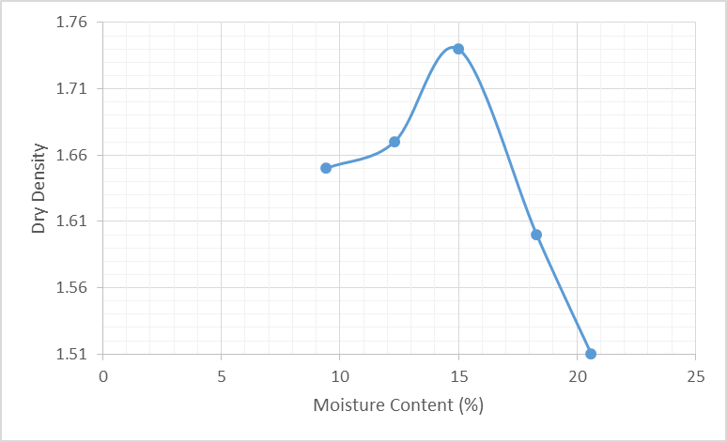
_{Form S5} MAX. DRY DENSITY: 1.78 Kg. /Cum OPTIMUM M/C: 15.3 %

Operator: K.A Boloko Checked: Engr. K. A. Boloko Date: 27/07/2022
Description: (Pit 3)
No. of layers: 3 No. of blows: 27
Wt. of mould: 3500 g Vol. of mould (v): 1000

9 % 12 % 15% 18% 21 %
1. Test No. | 1 | 2 | 3 | 4 | 5
2. Container No. | 37 | 55 | 107 | 2 | 133
3. Wt. of Container + Wet Soil | 54.3 | 66.0 | 78.3 | 56.7 | 59.1
4. Wt. of Container + Dry Soil | 50.9 | 60.4 | 70.1 | 50.1 | 51.2
5. Wt. of Container | 14.5 | 14.7 | 16.7 | 14.0 | 13.7
6. Wt. of Moisture | 3.4 | 5.6 | 8.2 | 6.6 | 7.9
7. Wt. of Dry Soil | 36.4 | 45.7 | 53.4 | 36.1 | 37.5
8. Moisture Content (m %) | 9.3 | 12.3 | 15.4 | 18.3 | 21.1
9. Wt. of Mould + wet Soil ( ) | 5068 | 5149 | 5271 | 5239 | 5192
10. Wt. of Wet Soil (w) | 1637 | 1718 | 1840 | 1808 | 1761
11. Bulk Density D_{w}= | 1.64 | 1.72 | 1.84 | 1.81 | 1.76
12. Dry Density= | 1.50 | 1.53 | 1.59 | 1.53 | 1.45
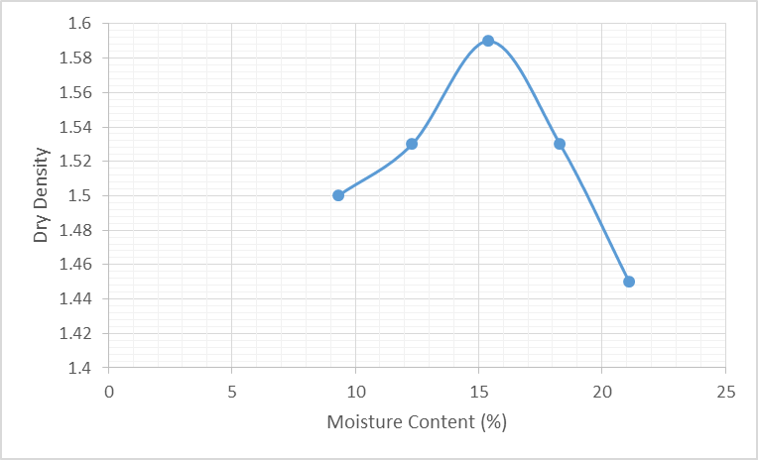
_{Form S5} MAX. DRY DENSITY: 1.59 Kg. /Cum OPTIMUM M/C: 15.5 %

Operator: K.A Boloko Checked: Engr. K. A. Boloko Date: 27/07/2022
Description: (Pit 4)
No. of layers: 3 No. of blows: 27
Wt. of mould: 3609 g Vol. of mould (v): 1000

6% 9% 12% 15% 18%
1. Test No. | 1 | 2 | 3 | 4 | 5
2. Container No. | 04 | 03 | 16 | 07 | 39
3. Wt. of Container + Wet Soil | 40.0 | 47.6 | 49.6 | 50.5 | 51.1
4. Wt. of Container + Dry Soil | 38.5 | 44.8 | 45.8 | 45.6 | 46.0
5. Wt. of Container | 14.1 | 14.5 | 14.5 | 13.7 | 18.1
6. Wt. of Moisture | 1.5 | 2.8 | 3.8 | 4.9 | 5.1
7. Wt. of Dry Soil | 24.4 | 30.3 | 31.3 | 31.9 | 27.9
8. Moisture Content (m %) | 6.1 | 9.2 | 12.1 | 15.4 | 18.3
9. Wt. of Mould + wet Soil ( ) | 5080 | 5184 | 5282 | 5178 | 4993
10. Wt. of Wet Soil (w) | 2046 | 2150 | 2248 | 2144 | 1959
11. Bulk Density D_{w}= | 2.05 | 2.15 | 2.25 | 2.14 | 1.96
12. Dry Density= | 1.93 | 1.97 | 2.01 | 1.85 | 1.66

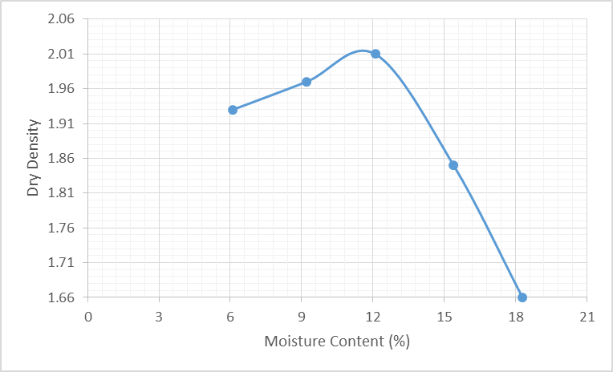
_{Form S5} MAX. DRY DENSITY: 2.01 Kg. /Cum OPTIMUM M/C: 12.1 %

Operator: K.A Boloko Checked: Engr. K. A. Boloko Date: 27/07/2022

Location: Benue State University, Makurdi Operator: ……..
Description: (Pit 5) Date: 27/07/22
No. of layers: 3 No. of blows: 27
Wt. of mould: 3609 g Vol. of mould (v): 1000

12% 15% 18% 21% 24%
13. Test No. | 1 | 2 | 3 | 4 | 5
14. Container No. | 60 | 30 | 10 | 101 | 81
15. Wt. of Container + Wet Soil | 84.7 | 102.4 | 110.3 | 111.7 | 113.8
16. Wt. of Container + Dry Soil | 77.6 | 91.2 | 95.0 | 95.8 | 95.0
17. Wt. of Container | 16.5 | 16.0 | 16.0 | 16.0 | 16.0
18. Wt. of Moisture | 7.1 | 11.2 | 14.5 | 16.7 | 18.8
19. Wt. of Dry Soil | 61.1 | 75.2 | 79.8 | 78.9 | 79.0
20. Moisture Content (m %) | 11.6 | 14.9 | 18.2 | 21.2 | 23.8
21. Wt. of Mould + wet Soil ( ) | 5115 | 5475 | 5268 | 5225 | 5055
22. Wt. of Wet Soil (w) | 1595 | 1655 | 1748 | 1705 | 1535
23. Bulk Density D_{w}= | 1.60 | 1.66 | 1.75 | 1.71 | 1.54
24. Dry Density= | 1.40 | 1.44 | 1.48 | 1.41 | 1.24

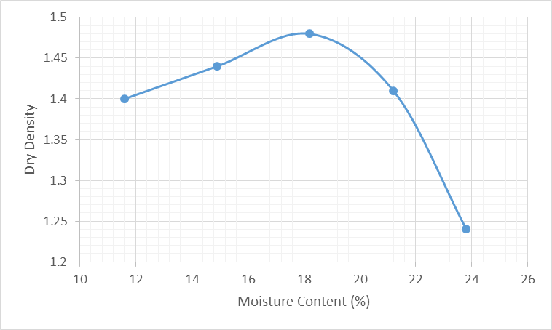
_{Form S5} MAX. DRY DENSITY: 1.48 Kg. /Cum OPTIMUM M/C: 18.2 %

Operator: K.A Boloko Checked: Engr. K. A. Boloko Date: 27/07/2022 Undrained shear box test for PIT 1
Test No Total normal stress (kPa) Total stress at failure (kPa)
 | 1 |  | 25 |  | 13
 | 2  3  4 |  | 50 |  | 26
 |  |  | 102 |  | 53
 |  |  | 152 |  | 82
Correlation coefficient = 0.999606
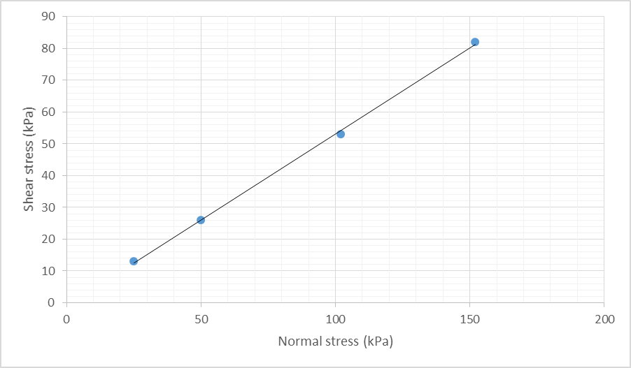
Cohesion = | 0 | kPa  o
Angle of friction = | 27

Undrained shear box test for PIT 2
Test No Total normal stress (kPa) Total stress at failure (kPa)
 | 1 |  | 25 |  | 11
 | 2  3  4 |  | 50 |  | 25
 |  |  | 103 |  | 49
 |  |  | 153 |  | 80
Correlation coefficient = 0.99771
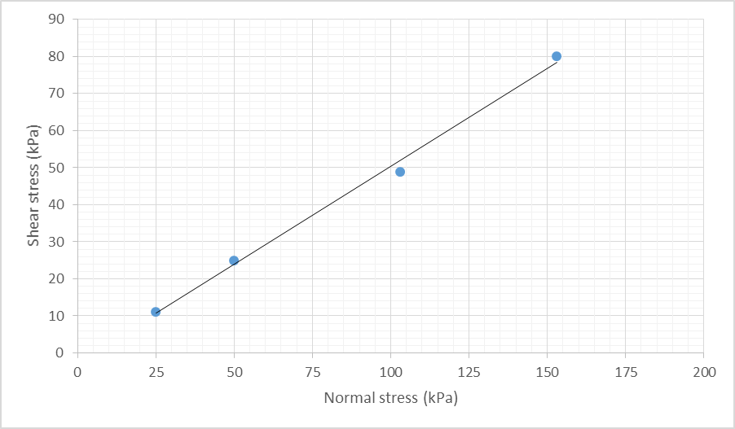
Cohesion = | 0 | kPa  o
Angle of friction = | 26

Undrained shear box test for PIT 3
Test No Total normal stress (kPa) Total stress at failure (kPa)
 | 1 |  | 25 |  | 12
 | 2  3  4 |  | 50 |  | 24
 |  |  | 103 |  | 50
 |  |  | 153 |  | 72
Correlation coefficient = 0.999684
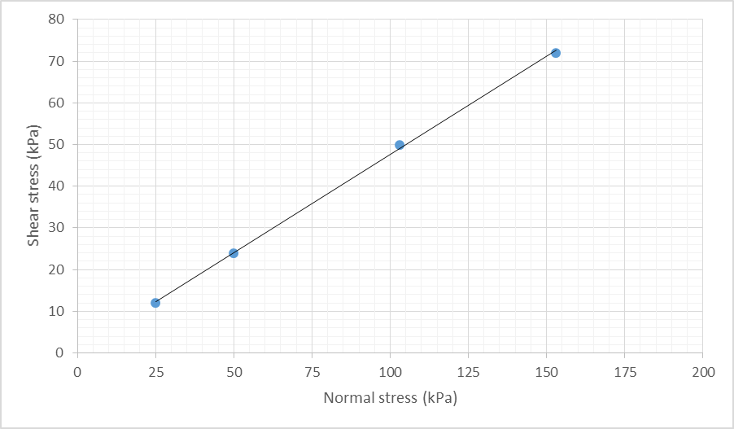
Cohesion = | 0 | kPa  o
Angle of friction = | 26

Undrained shear box test for PIT 4
Test No Total normal stress (kPa) Total stress at failure (kPa)
 | 1 |  | 25 |  | 12
 | 2  3  4 |  | 50 |  | 24
 |  |  | 103 |  | 48
 |  |  | 153 |  | 72
Correlation coefficient = 0.999665
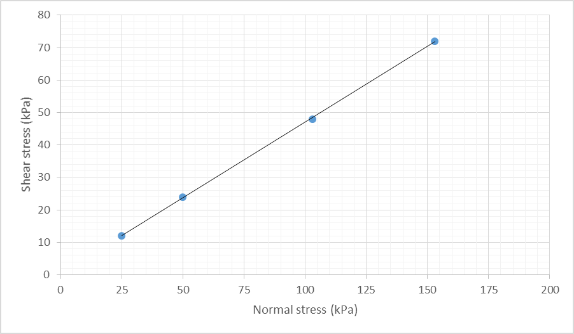
Cohesion = | 0 | kPa  o
Angle of friction = | 25

Undrained shear box test for PIT 5
Test No Total normal stress (kPa) Total stress at failure (kPa)
 | 1 |  | 25 |  | 13
 | 2  3  4 |  | 50 |  | 23
 |  |  | 103 |  | 45
 |  |  | 153 |  | 64
Correlation coefficient = 0.999164
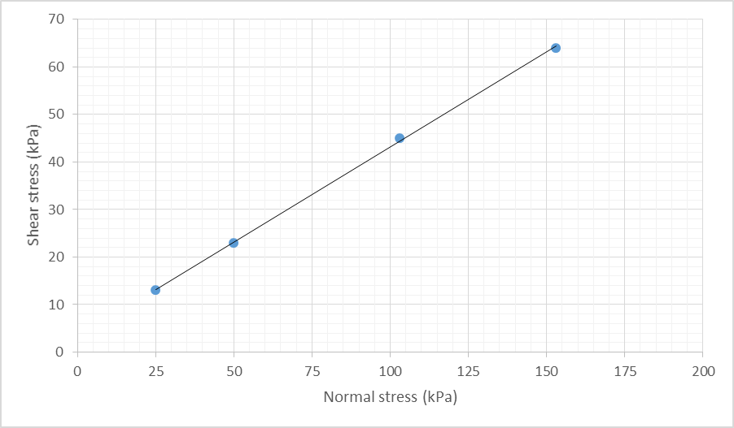
Cohesion = | 0 | kPa  o
Angle of friction = | 28

